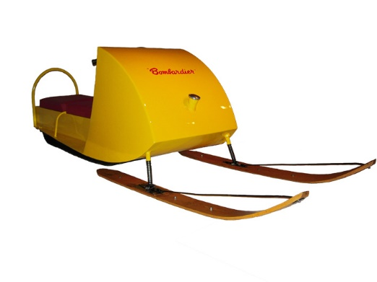

“If you want to go fast, go alone. If you want to go far, go together”.
-African Proverb
* CTRL + Click on photo to go to hyperlink

Communication/where to find us:
https://twitter.com/21gravel | Please follow for Career Development tweets, and link to Trade Talk Thursday
https://drive.google.com/folderview?id=0Bw590bI7iOboMmczNmw2azVkQzQ&usp=sharing | Trade Talk Thursday archives
http://www.mapleforem.ca/ | Educators join the Manitoba professional learning environment. Trade Talk Thursday is now being posted to the Career Development Community
https://paper.li/ | Interested in making your own edition of the career development daily. go to paper.li to find out more
http://lakeshoretransitions.weebly.com/ | Visit Lakeshore School Division’s Transitions web page for post-secondary and career development resources and more ….
http://manitobacareerprospects.ca/news.asp | Visit Manitoba career prospects news and events page for the latest career development information
http://www.manitobacareerdevelopment.ca/CDI/index.html | Province of Manitoba’s Career Development site

FYI:
Winnipeg Repair Education and Cycling Hub (WRENCH), a Winnipeg-based bicycle charity | “The sixth annual Cycle of Giving event at Rossbrook House, a safe space for youth on Ross Avenue, turned a trailer full of kids bikes into holiday presents over the weekend.” | http://www.cbc.ca/news/canada/manitoba/cycle-of-giving-24-hour-bike-fixing-marathon-brings-fresh-wheels-to-manitoba-kids-1.3891589
World Skills Competition Abu Dhabi October 14-19 2017 | Young people from 76 member countries and regions will come to Abu Dhabi to compete in around 50 skill competitions.  302 days 2 hours to go! | https://worldskillsabudhabi2017.com/en
Lake Winnipeg Foundation Newsletter  “The Watershed Observer”. Check out the MANITOBA KIDS TAKE ACTION article on page 9 | . “Grade 5 students from Lord Nelson School made and sold phosphate-free, microbead-free soaps. Students at Ryerson Elementary School made and sold lake-friendly cleaning products and created an informative video. Grade 7 students at Teulon Collegiate organized a gaming tournament.” | http://www.lakewinnipegfoundation.org/sites/default/files/LWF%20newsletter%20Fall%20Winter%202016.pdf?platform=hootsuite
Pilot project making winter travel safer for people in Pond Inlet, Nunavut CBC news article | ” I can tell local people how thick the ice is on areas they go camping or hunting."  SmartICE, a unique sea ice monitoring system developed for coastal communities by researchers at Memorial University in Newfoundland, and is being piloted in Pond Inlet. | http://www.cbc.ca/news/canada/north/smart-ice-pond-inlet-nunavut-1.3764542
The official NORAD Santa tracker site | ETA 8 days 13 hours 45minutes 05 seconds  Used to listen to CHTM 610 radio on Christmas Eve to get NORAD updates on Santa’s progress. Now can follow on official website. | http://www.noradsanta.org/
This igloo greenhouse could revolutionize food production in the North. CBC news story | A Ryerson University student has built a greenhouse on the Arctic Circle that allows people in the far North to grow fresh produce. | http://www.cbc.ca/news/thenational/this-igloo-greenhouse-could-revolutionize-food-production-in-the-north-1.3698224
Edible trees grant opportunity $4000  Due February 24, 2017. | “The program offers funding of up to $4,000 and other resources for community-based projects that provide residents with access to fresh fruit and nut trees while making a positive difference to the Canadian environment.” | http://campaign.r20.constantcontact.com/render?m=1108926844282&ca=a26c9ba7-0879-41cb-bb59-cdca2f8fb901
Northern Manitoba Food, Culture, and Community Collaborative (NMFCCC)  Stories of Communities  Leading Change | “Fishing cooperatives, gardens, wild food programs, bee apiaries and greenhouses — “these are just some of the ways northerners are using food to build community, improve health, strengthen local economies, provide opportunity for youth and reclaim culture.”  Check out beekeeping on page 13. | http://nmfccf.weebly.com/uploads/4/4/1/7/44170639/nmfccc_final_20160503__non-spread_.pdf
Using Kinetic energy to recharge our batteries article | "We're on the path toward wearable devices powered by human motion,  Keyboards could render power from typing fingers and feed it to laptop batteries; fitness trackers could be powered by the kinetics of jogging feet”. | http://www.upi.com/Science_News/2016/12/09/Flexible-device-harvests-energy-from-basic-motions-like-a-finger-swipe/4081481291601/?spt=mps&or=6&sn=sn
Top of the Lake Snowmobile Museum | Ski-doo, Arctic Cat, Polaris, Sno-jet, Sno-Prince, Phantom, Bearcat, Harley Davidson, John Deere, Fox-trac, Hus-ski…they have them all! Check out the sleds on display section. | http://www.snowmobilemuseum.com/
Ctrl + click to take you to the correct link

