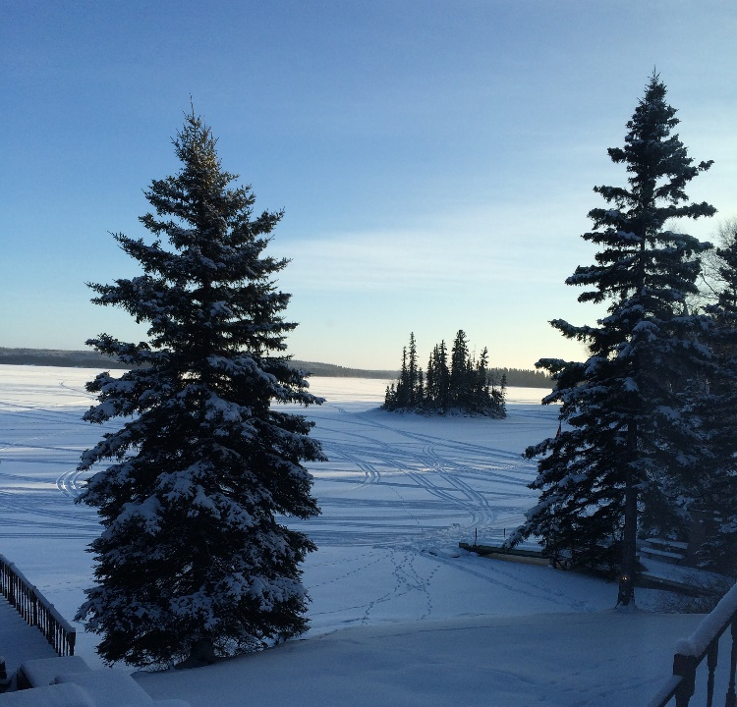

"How many lessons of faith and beauty we should lose, if there were no winter in our year!"
--Thomas Wentworth Higginson
Communication/where to find us:
https://twitter.com/21gravel | Please follow for Career Development tweets ,and link to Trade Talk Thursday
https://drive.google.com/folderview?id=0Bw590bI7iOboMmczNmw2azVkQzQ&usp=sharing | Trade Talk Thursday archives
http://www.mapleforem.ca/ | Educators join the Manitoba professional learning environment. Trade Talk Thursday is now being posted to the Career Development Community
https://paper.li/21GRAVEL/1457619310?edition_id=a1b2b1e0-3303-11e6-8311-002590a5ba2d&utm_campaign=paper_sub&utm_medium=email&utm_source=subscription | This week’s edition of the career development daily on paper.li
http://lakeshoretransitions.weebly.com/ | Visit Lakeshore School Division’s Transitions web page for post-secondary and career development resources and more ….

FYI:
SFTT | Speech from the throne | http://www.gov.mb.ca/thronespeech/
Everfi’s Hockey scholar demo | “Future Goals - Hockey Scholar uses sports to bring life to science, math and engineering concepts. Through 12 inquiry-based lessons, students explore topics such as phases of matter, forces and motion, and body systems. These are all available to your classroom at no cost thanks to the Calgary Flames, the NHL and NHLPA.” | https://vimeo.com/132331177?mkt_tok=eyJpIjoiWlRnM09XSmlPVGN3TnpreCIsInQiOiI3NVZURzVsV1h4ZFZKWERyXC9rSTBKdVczOUFiK0RXTU00MWdmVUREMUdTRktlOXlhcmF6ZHkzQnZ0Yjc3V0pXTHpFWGZVOU5HN3hlM3ZHMUdNTkVHZUl6VHZcL1dPcnMwVHZ4YW1zWVBBNkpZPSJ9
Middle Years Trades Camp in Borderland and Red River Valley  article | Students from Borderland and Red River Valley School Divisions took part in a Trades Camp initiative through the month of November. The two school divisions received a grant from Apprenticeship Manitoba that was used to provide hands on trades experience for middle years students in eight vocational programs operated by the Red River Technical Vocational Area. | http://www.pembinavalleyonline.com/local/sixteen-middle-years-students-enjoy-trades-camp
Skills Canada contest description document: Robotics example | Contest description for Robotics | http://www.skillsmanitoba.ca/wp-content/uploads/2013/08/23_Robotics_S_2016.pdf
Campus Manitoba career planning resource | ​ “Career options are endless. Sorting them on your own can be hard. We’ve got a nice list of what you can find right here in Manitoba.” | http://www.setyourcourse.ca/career-planning
Lets talk science programs | This CurioCity resource is designed to showcase STEM-based careers – both the obvious and the not so obvious. | https://explorecuriocity.org/Explore/ArticleId/4853/careers.aspx
TIME TO START THINKING ROTARY CAREER SYMPOSIUM!!!  DATES: MARCH 15-16, 2017  PLACE: WINNIPEG CONVENTION CENTRE | “The Rotary Career Symposium Committee is pleased to announce we have finalized dates, places and people for our 20th Annual event.”  School registration form is attached . | https://drive.google.com/file/d/0Bw590bI7iObocDFxeVRGeFZHcEE/view?usp=sharing
explorecuriocity.org Free STEM career resources for educators | “Make science, technology, engineering and math (STEM) engaging, relevant and interesting for your students. Explore and access practical, curriculum-aligned classroom resources like learning strategies, starting points, case studies, action project resources and timeline guides. Login or register for full access to all of our free educator resources.” | https://explorecuriocity.org/Explore/ArticleId/5027/careers-educator-resource.aspx
Friendship Centres of Manitoba | The Winston Menard Memorial Scholarships are awarded to students needing support for their education. Students must demonstrate a commitment to volunteerism, community development, and helping others. | http://www.friendshipcentres.ca/scholarships/
Skills Canada Manitoba Fall and Winter Programs | “Skills Canada Manitoba is pleased to offer a variety of exciting programs this Fall and Winter to students in Grades 6 - 12.” | https://t.e2ma.net/message/xozyk/1fbdet

