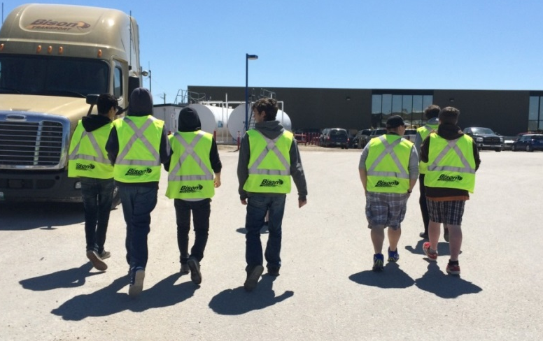

““Wise words are like seeds. The more you scatter them, the more they will grow into infinite gardens of knowledge.”
― Rise Up and Salute the Sun: The Writings of Suzy Kassem

Communication/where to find us:
https://twitter.com/21gravel | Please follow for Career Development tweets ,and link to Trade Talk Thursday
https://drive.google.com/folderview?id=0Bw590bI7iOboMmczNmw2azVkQzQ&usp=sharing | Trade Talk Thursday archives
http://www.mapleforem.ca/ | Educators join the Manitoba professional learning environment. Trade Talk Thursday is now being posted to the Career Development Community
https://paper.li/21GRAVEL/1457619310?edition_id=a1b2b1e0-3303-11e6-8311-002590a5ba2d&utm_campaign=paper_sub&utm_medium=email&utm_source=subscription | This week’s edition of the career development daily on paper.li
http://lakeshoretransitions.weebly.com/ | Visit Lakeshore School Division’s Transitions web page for post-secondary and career development resources and more ….

FYI:
Red River College billboard campaign | “We want to celebrate the success of our alumni and the diverse, innovative organizations that hire them. Building on the momentum of our previous billboard campaigns, we invite you to join us in a creative co-op advertising opportunity.” | https://blogs.rrc.ca/marketing/billboards/
Beyond STEM webinar series | “Discover the essential elements of building a robust STEM program that transforms learning and improves outcomes in a highly engaging, relevant and incredibly dynamic environment. One that not only cultivates the skills of the General Capabilities but includes the first-ever system for their assessment!” | http://hub.globaldigitalcitizen.org/beyond-stem-nov-2016?mc_cid=a8f0fba2c9&mc_eid=aa8e08da49
Winnipeg Free Press article: “ Giving jobs to the hard to hire” | Agency successful at turning temporary jobs into full-time positions | http://www.winnipegfreepress.com/business/giving-jobs-to-the-hard-to-hire-400921551.html
Fire Spirit : unlocking First Nation and Northern Human Resources potential | “We deliver employment services and capacity building to aboriginal people and northern communities while connecting employers to a skilled aboriginal workforce “ | http://www.fire-spirit.ca/
YES resources for educators | “While our services are accessible in our offices, we have been purposeful in working to expand our efforts within high schools to assist youth in their first stages of career exploration. These connections allow us to deliver programs and services that are a direct link to the current provincial curricula and assists youth to connect their school learning with workplace and labour market realities. This is a free resource we encourage teachers and other educators to access. “  ​ | http://www.youthemploymentservices.com/educators  http://media.wix.com/ugd/224d25_c003ce2970004e74bcff86e2709fbb93.pdf
Manitoba Career Prospects News and Events page | “Manitoba Career Prospects is a program to help you discover the different career opportunities available in Manitoba. We will connect you with industry professionals and employers who are looking to build their business with engaged and energetic Manitoba Youth.” | www.manitobacareerprospects.ca
November is Manitoba Career and Workforce Development Month | Ministers proclamation , events and resource links | http://www.manitobacareerdevelopment.ca/CDI/career_month/index.html
DISRUPTED: RBC Convention Centre  November 25 and 26 2016 | “Technology can be disruptive. Good. It’s about time we shake things up. Join us for two days of discourse on the future of STEM education” | http://www.educationdisrupted.ca/
Sidneyeve Matrix | DISRUPTED Keynote Address: Connected Classrooms & Personalized Platforms: Understanding Millennial Students’ Information Technology Needs | http://www.queensu.ca/filmandmedia/faculty-and-staff/faculty-and-staff-bios/sidneyeve-matrix
The Principal of Change: Stories of learning and leading Blog | 4 Ways to Lead and Create a “Culture of Innovation” From Any Position | http://georgecouros.ca/blog/archives/6855

